**Seneca College**

**Assignment 1**

**Paul Seung Kyung Kim**

**Brendan Yawney**

**GAM537 Section NSA**

**George Kougioumtzoglou**

**October 12, 2020**

Contents

Introduction 2

Methods to Access Game 2

The Game 2

Controls 3

Functional Requirements 4

Requirement: Two well-designed levels 4

Level - Dungeon 4

Level - Jungle 5

Requirement: 10 Objects 7

BP_Pickup 8

BP_Pickup_Shotgun 9

BP_Pickup_Thundergun 9

BP_Pickup_RocketLauncher 10

BP_Pickup_AssaultRifle 10

BP_Pickup_SniperRifle 11

BP_Pickup_GrenadeLauncher 11

BP_Pickup_Pistol 12

BP_Pickup_Railgun 12

BP_Pickup_Potion 13

Event Graph Example for all Pickups 13

BP_Launchpad 14

BP_Teleporter 15

BP_LevelTeleporter 16

Requirement: Pawn 18

BP_Player 18

Requirement: Environmental Lighting 20

Dungeon – Lighting 20

Jungle – Lighting 21

Requirement: Dynamic Lighting 22

Flashlight 22

Requirement: Terrain 23

Jungle 23

Forest 24

# Introduction

This document describes our video game BOOM and how it meets the functional requirements for GAM537 Assignment #1.

## Methods to Access Game

GitHub: <https://github.com/paulkim26/gam537-fps> (invitation sent to your GitHub ID: docie80)

YouTube: <https://www.youtube.com/watch?v=-ugy9mV_gms>

## The Game



BOOM is a fast-paced arena first person shooter featuring both gothic horror and science fiction elements. The levels are set in distinct arenas where players must fend off hordes of enemies for as long as possible.

The game draws inspiration from classic PC first person shooter games including:

* Quake III Arena (1999)
* Unreal Tournament (1999)
* DOOM (1993)

### Controls

|  |  |
| --- | --- |
| **Input** | **Function** |
| Mouse | Aim |
| Left-click | Fire |
| Mouse wheel down | Next weapon |
| Mouse wheel up | Previous weapon |
| W | Move forward |
| S | Move backward |
| A | Strafe left |
| D | Strafe right |
| F | Toggle flashlight |
| Space bar | Jump |
| 1 | Switch to weapon 1 |
| 2 | Switch to weapon 2 |
| 3 | Switch to weapon 3 |
| 4 | Switch to weapon 4 |
| 5 | Switch to weapon 5 |
| 6 | Switch to weapon 6 |
| 7 | Switch to weapon 7 |
| 8 | Switch to weapon 8 |

# Functional Requirements

## Requirement: Two well-designed levels

**“Two well-designed levels (though you can create multiple levels).”**

Level - Dungeon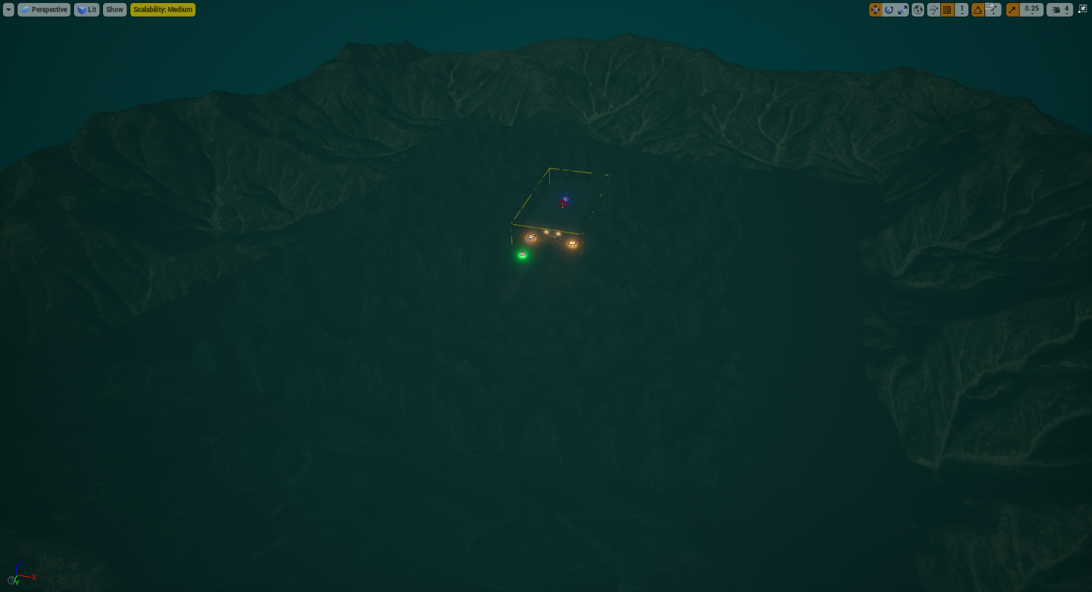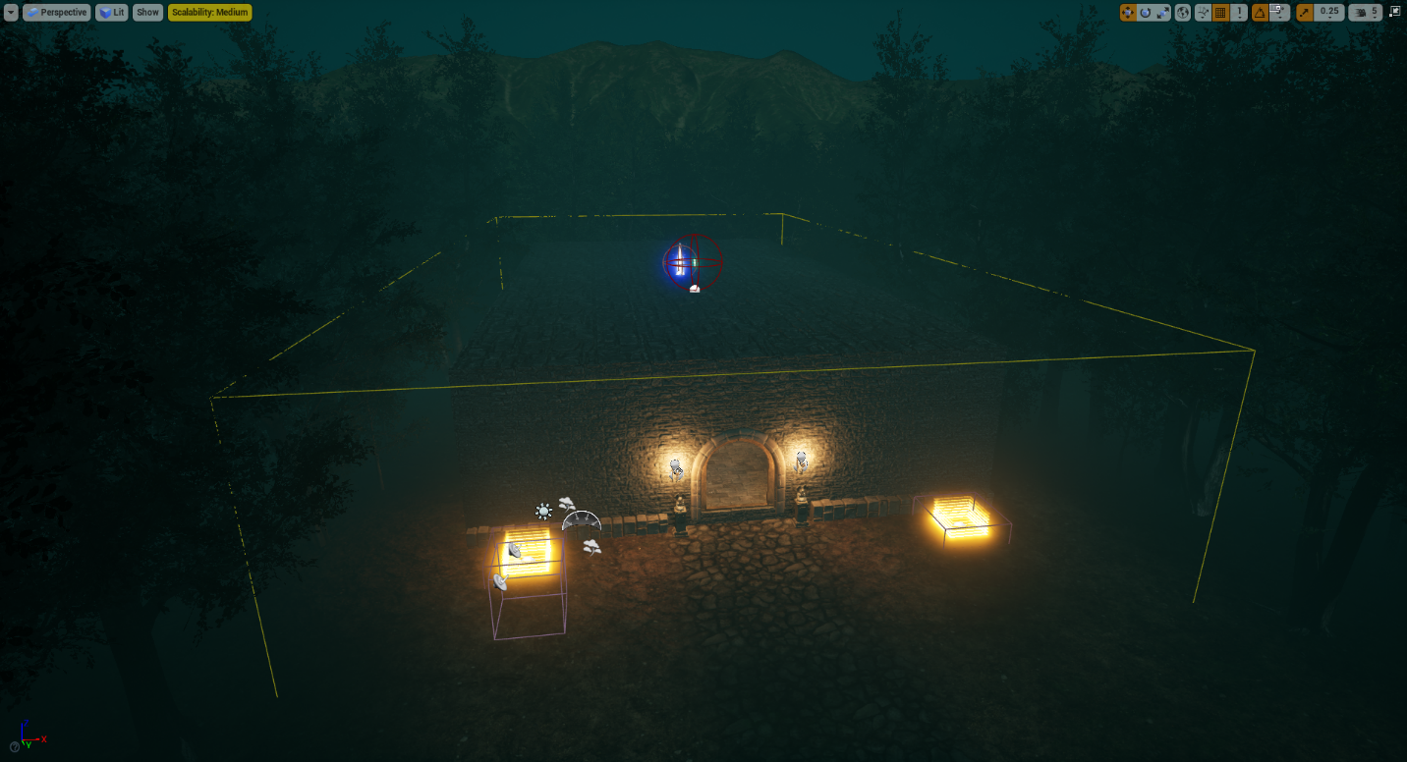

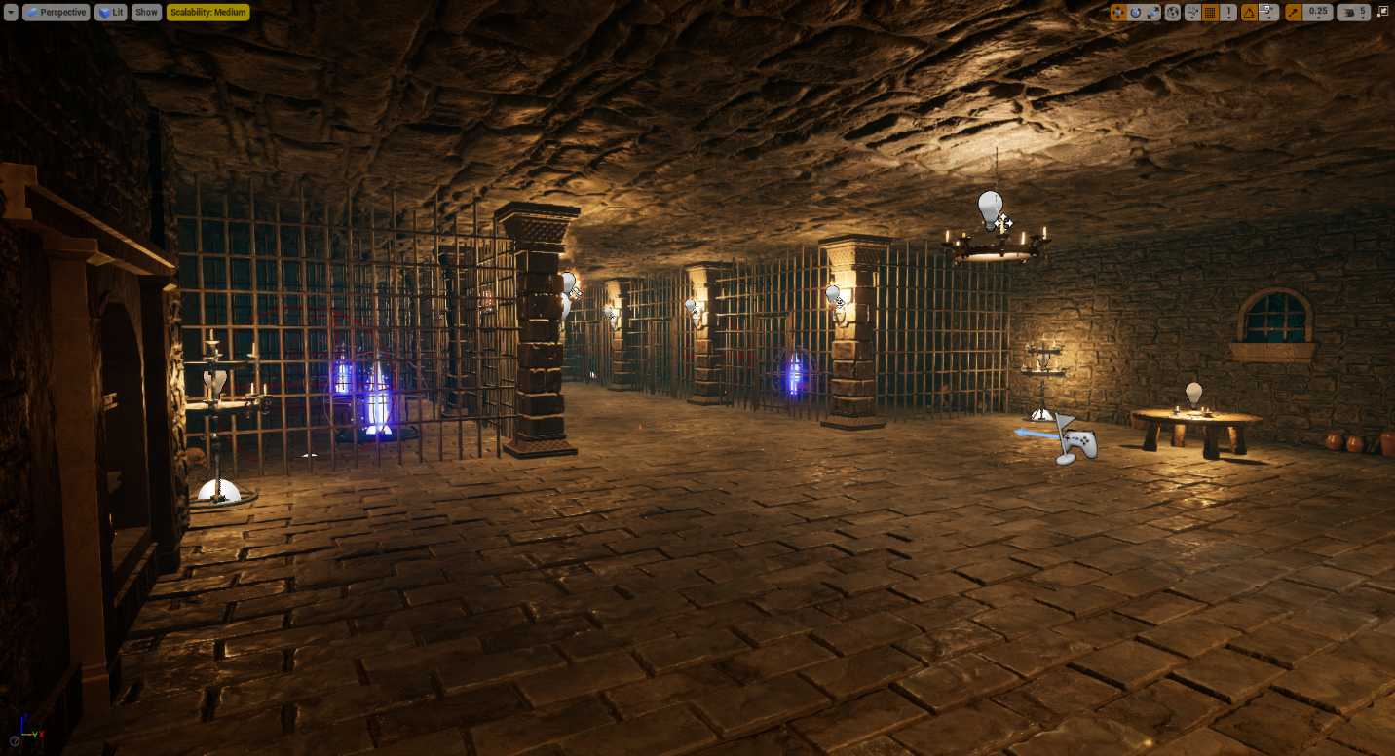

Level - Jungle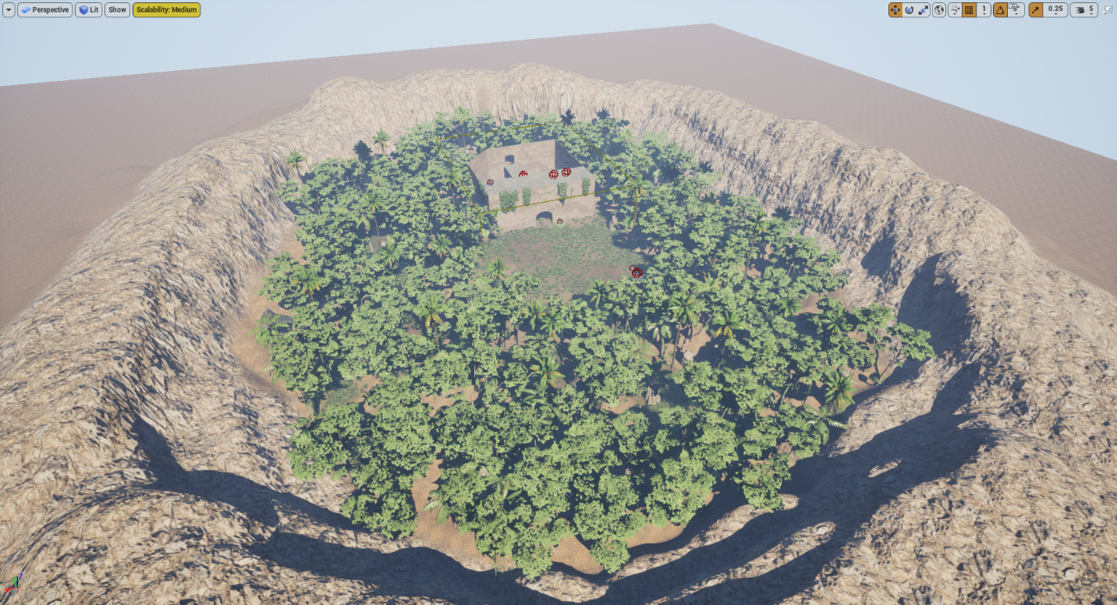

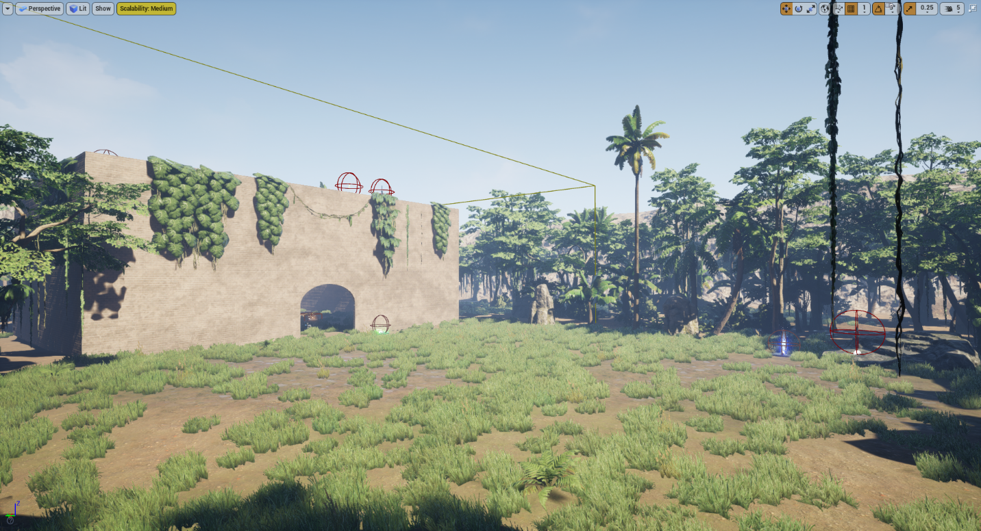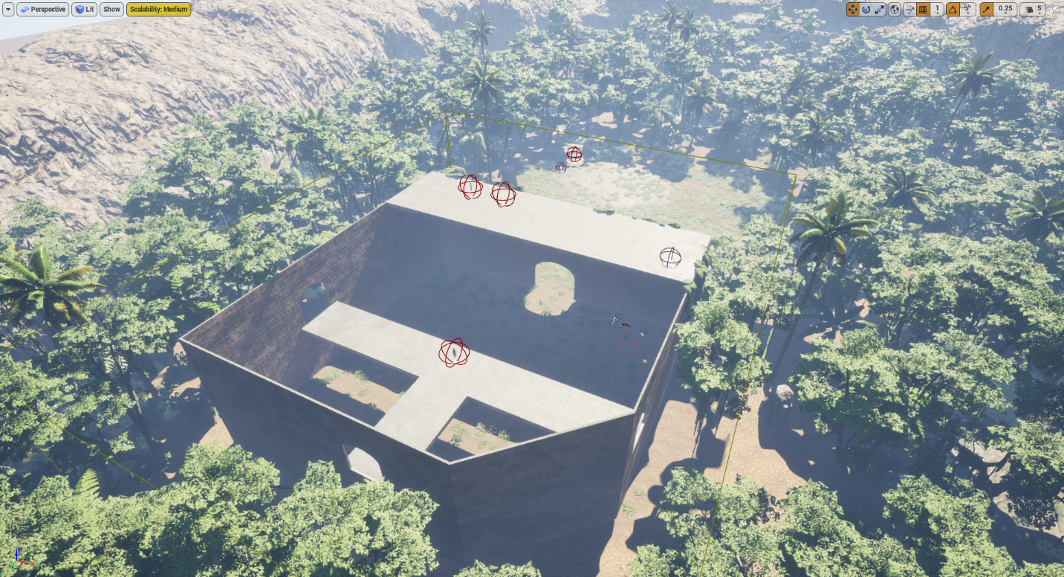

## Requirement: 10 Objects

**“A number of 10 objects designed in the Editor or designed in any other application or imported by any source. The objects should be blueprints with basic colliders and some functionality (your call).”**

Most of our objects come in the form of pickups that the player can collect around the 2 levels. Each pickup is derived from the same BP_Pickup class and thus share similar blueprints. The game also includes teleporters and launchpads with unique blueprints (note: some blueprints left out for the sake of simplicity).

### BP_Pickup

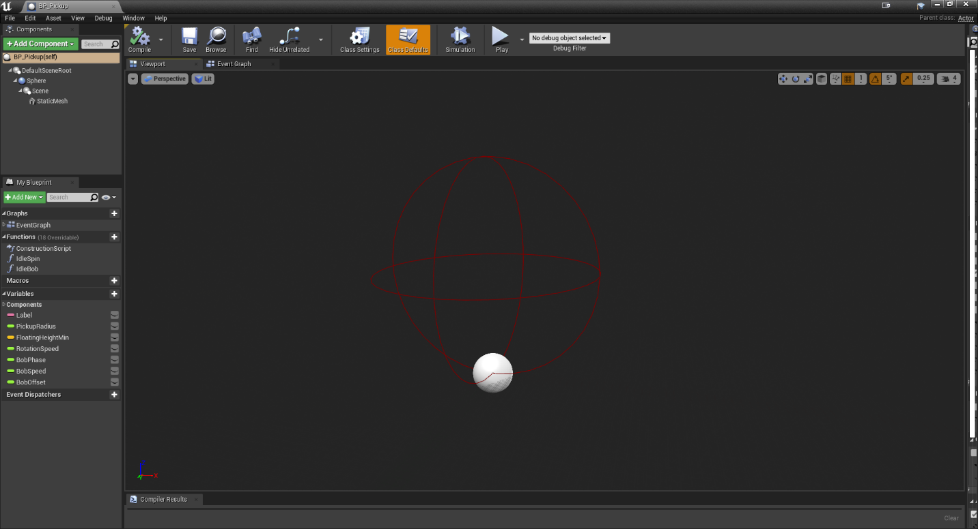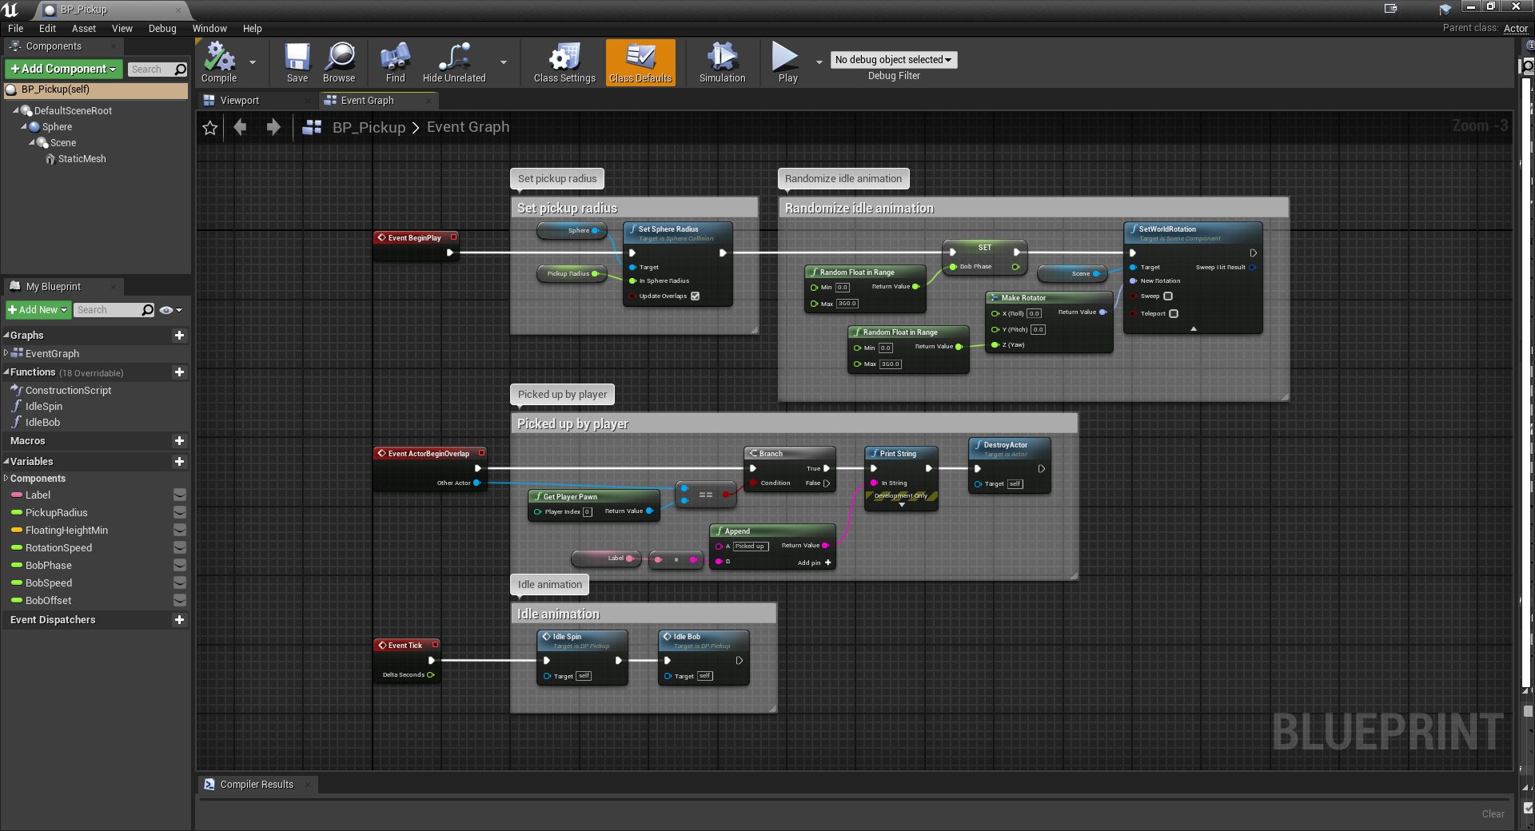

### BP_Pickup_Shotgun

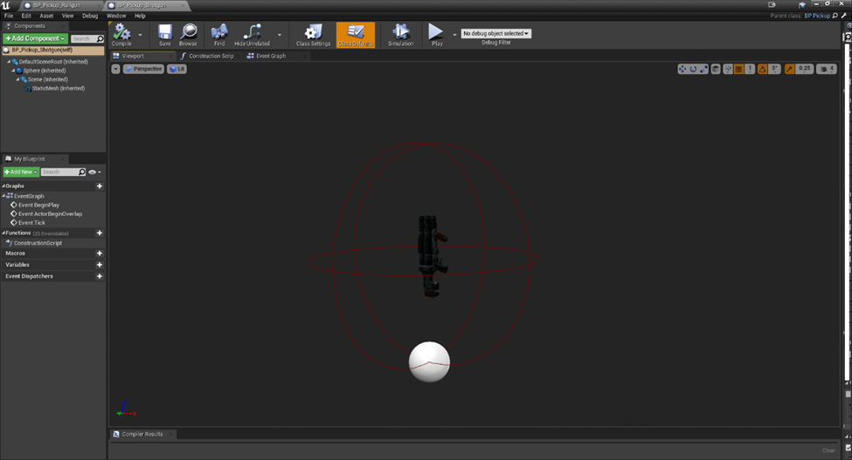

BP_Pickup_Thundergun 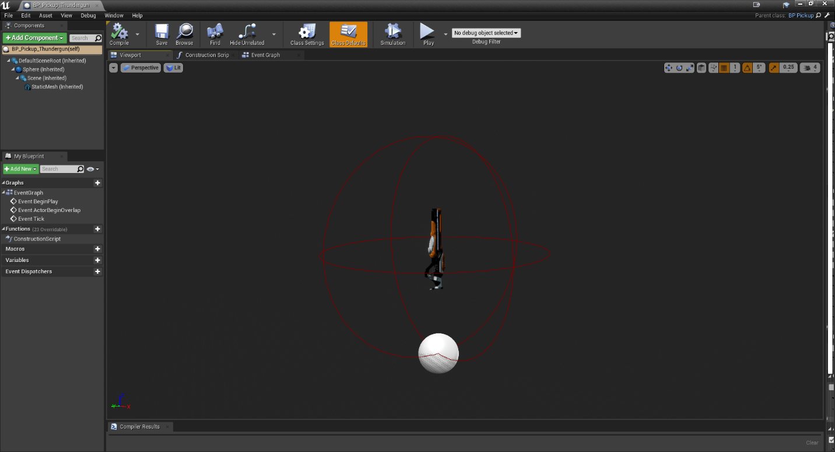

BP_Pickup_RocketLauncher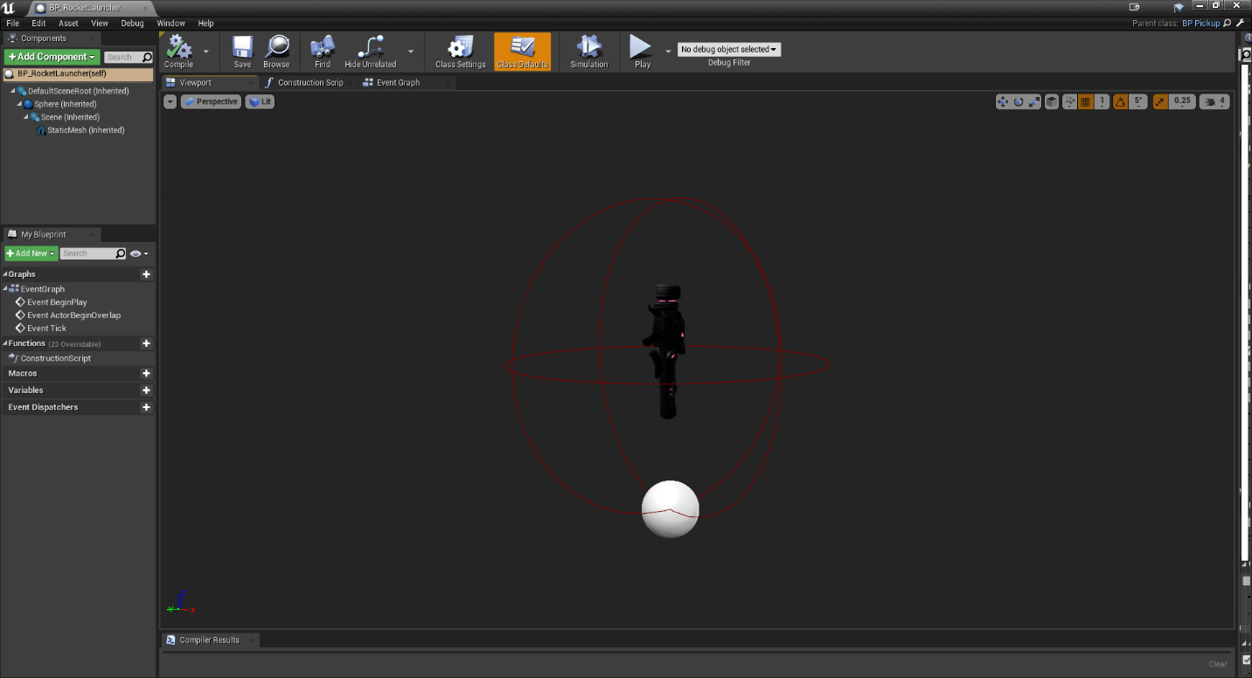

BP_Pickup_AssaultRifle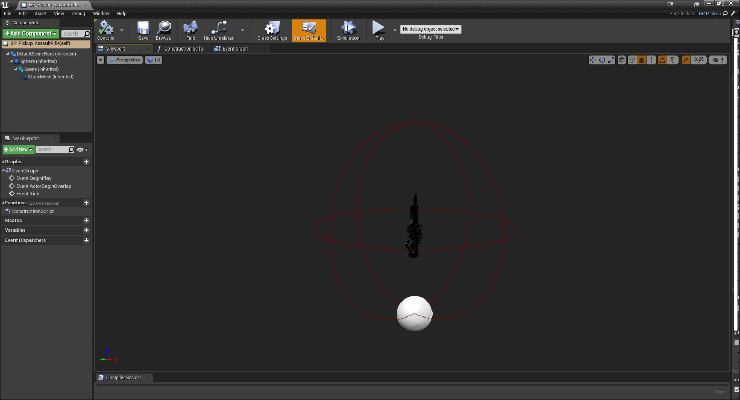

BP_Pickup_SniperRifle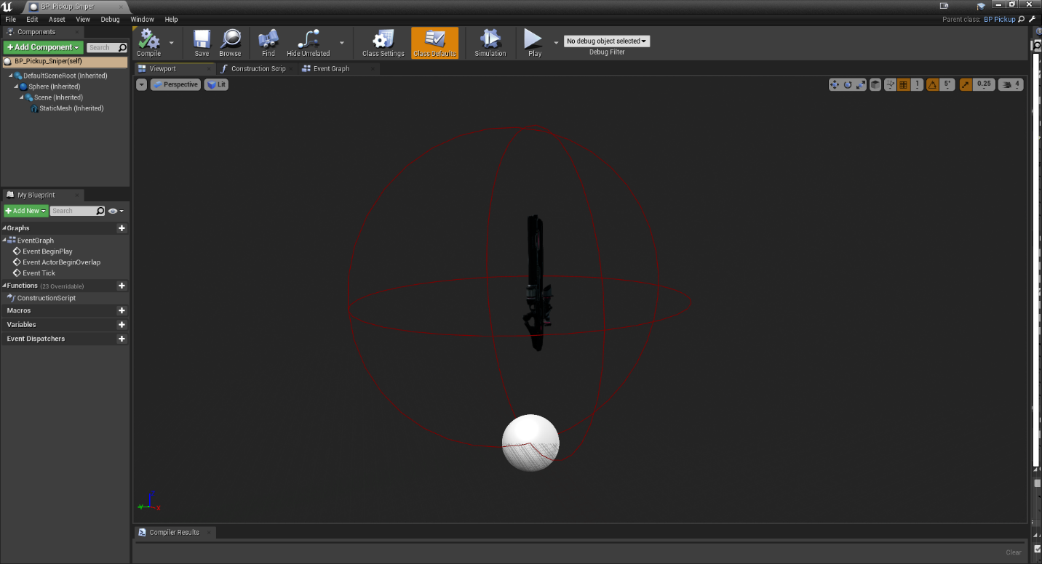

BP_Pickup_GrenadeLauncher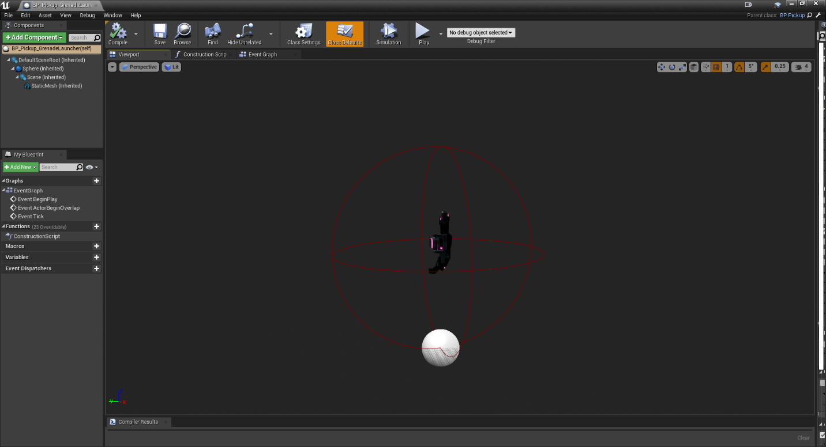

BP_Pickup_Pistol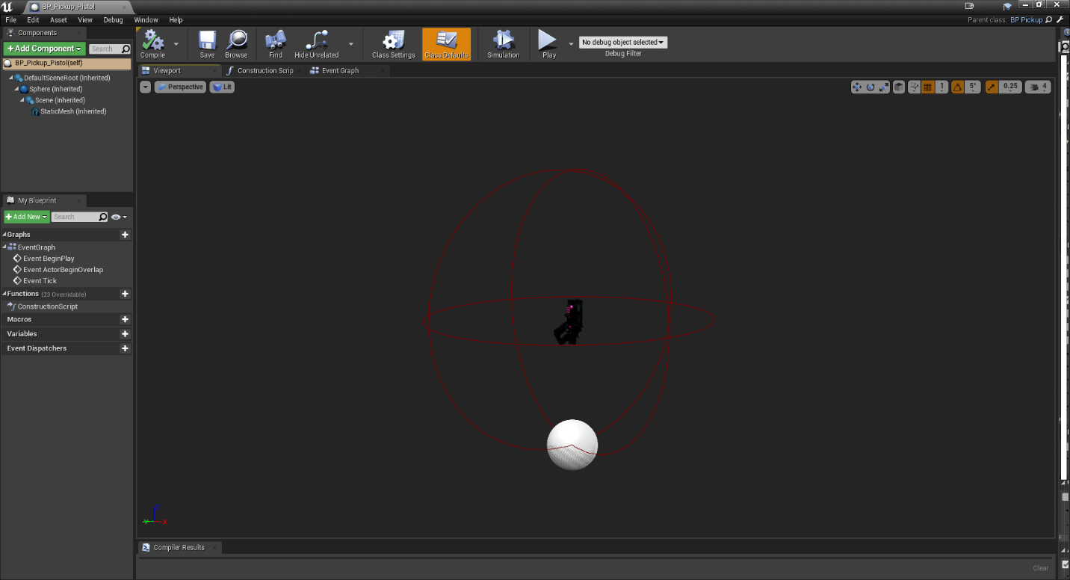

BP_Pickup_Railgun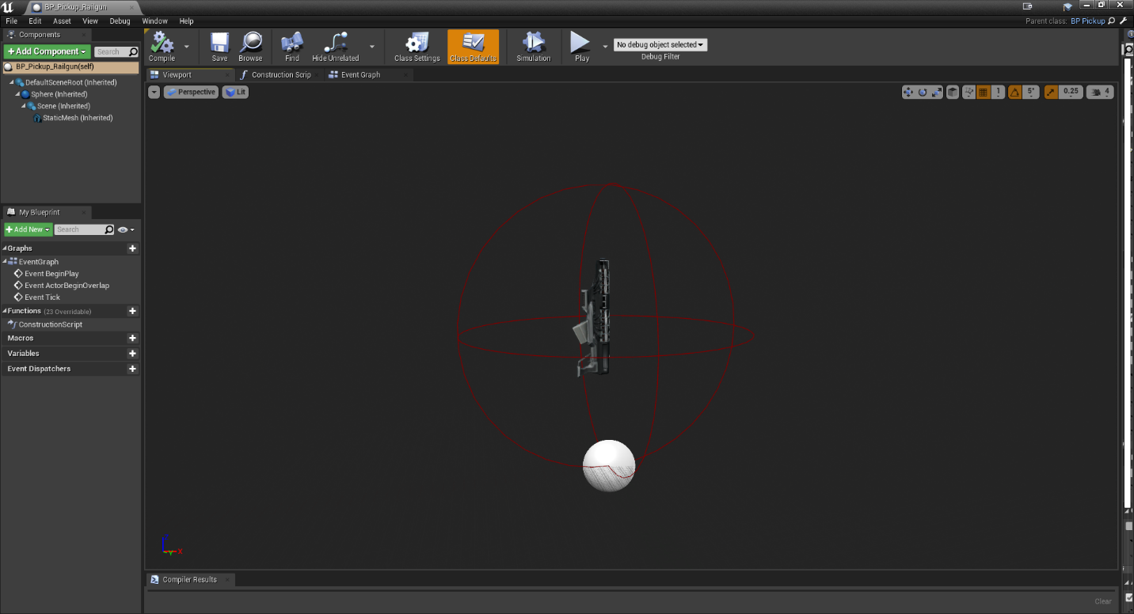

BP_Pickup_Potion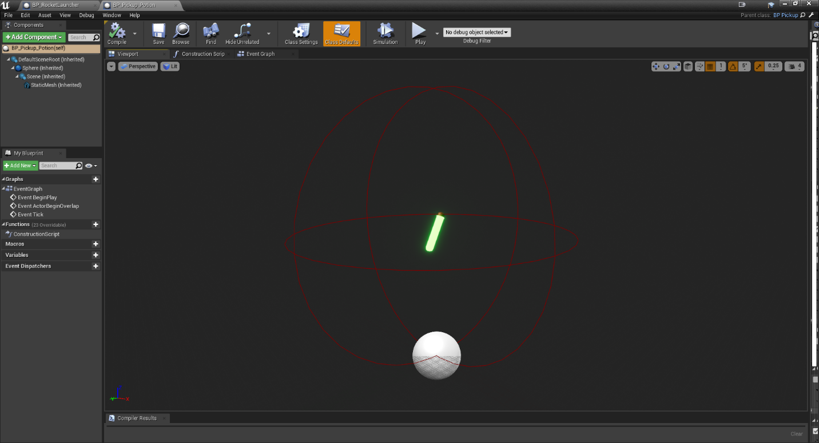

Event Graph Example for all Pickups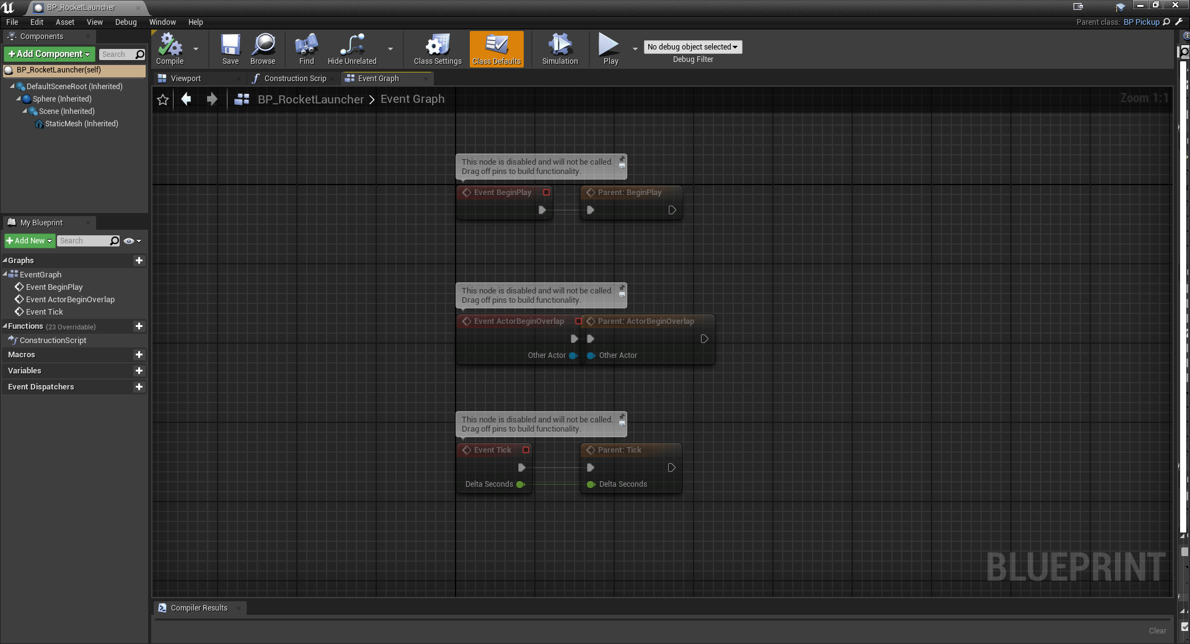

BP_Launchpad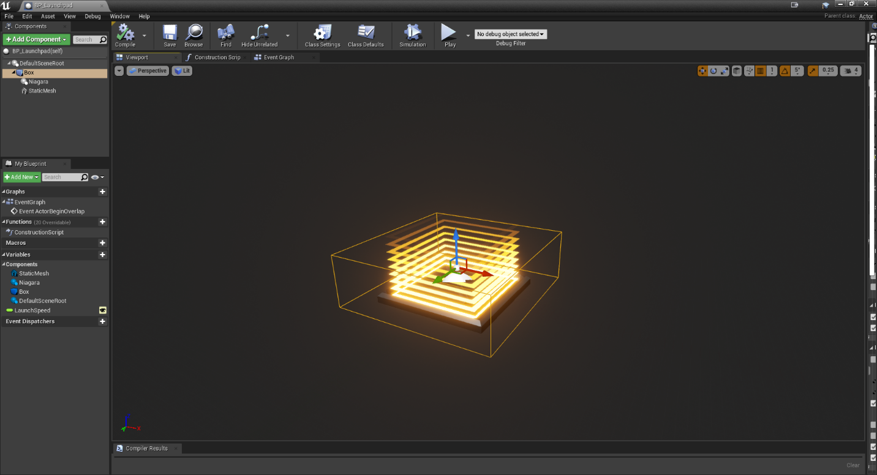

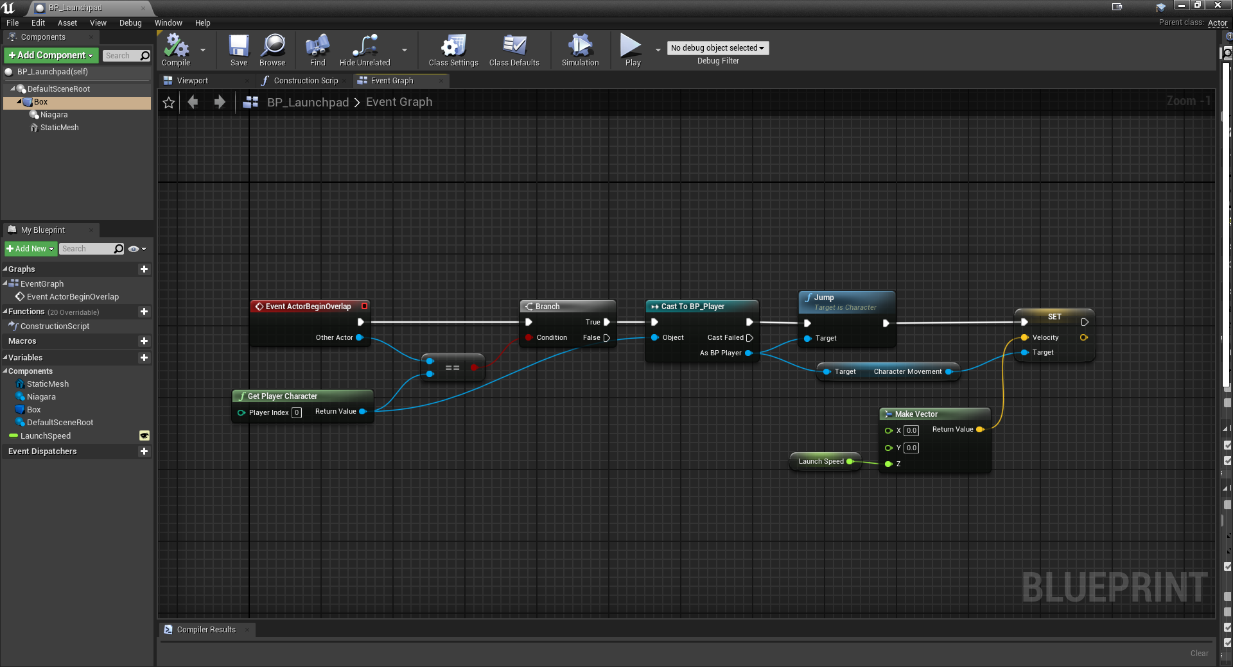

BP_Teleporter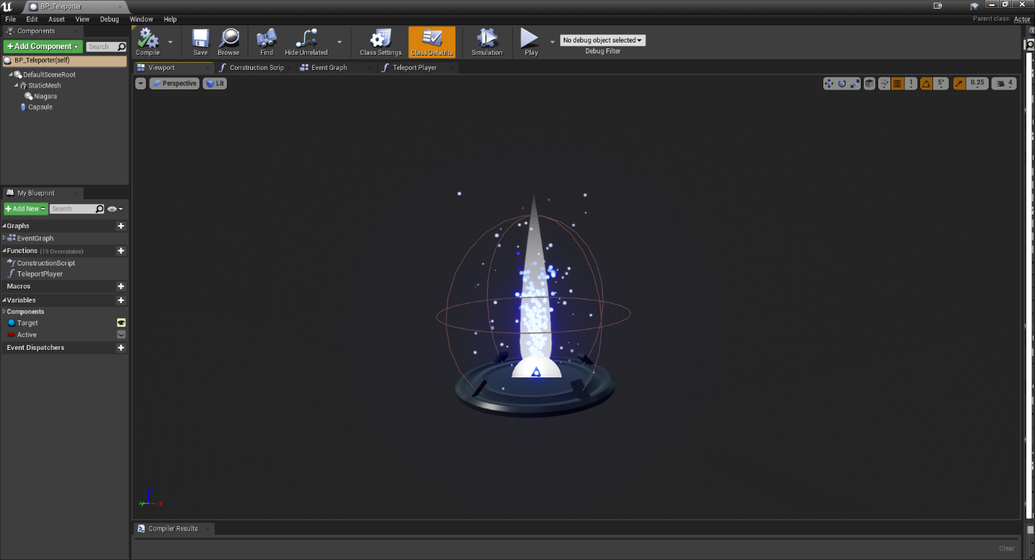

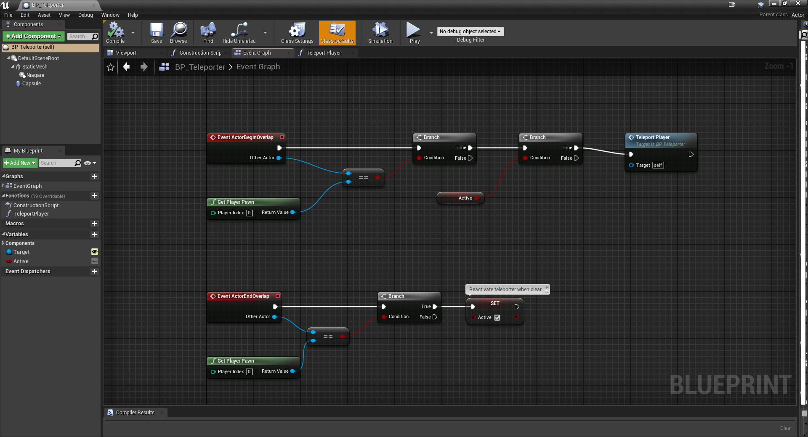

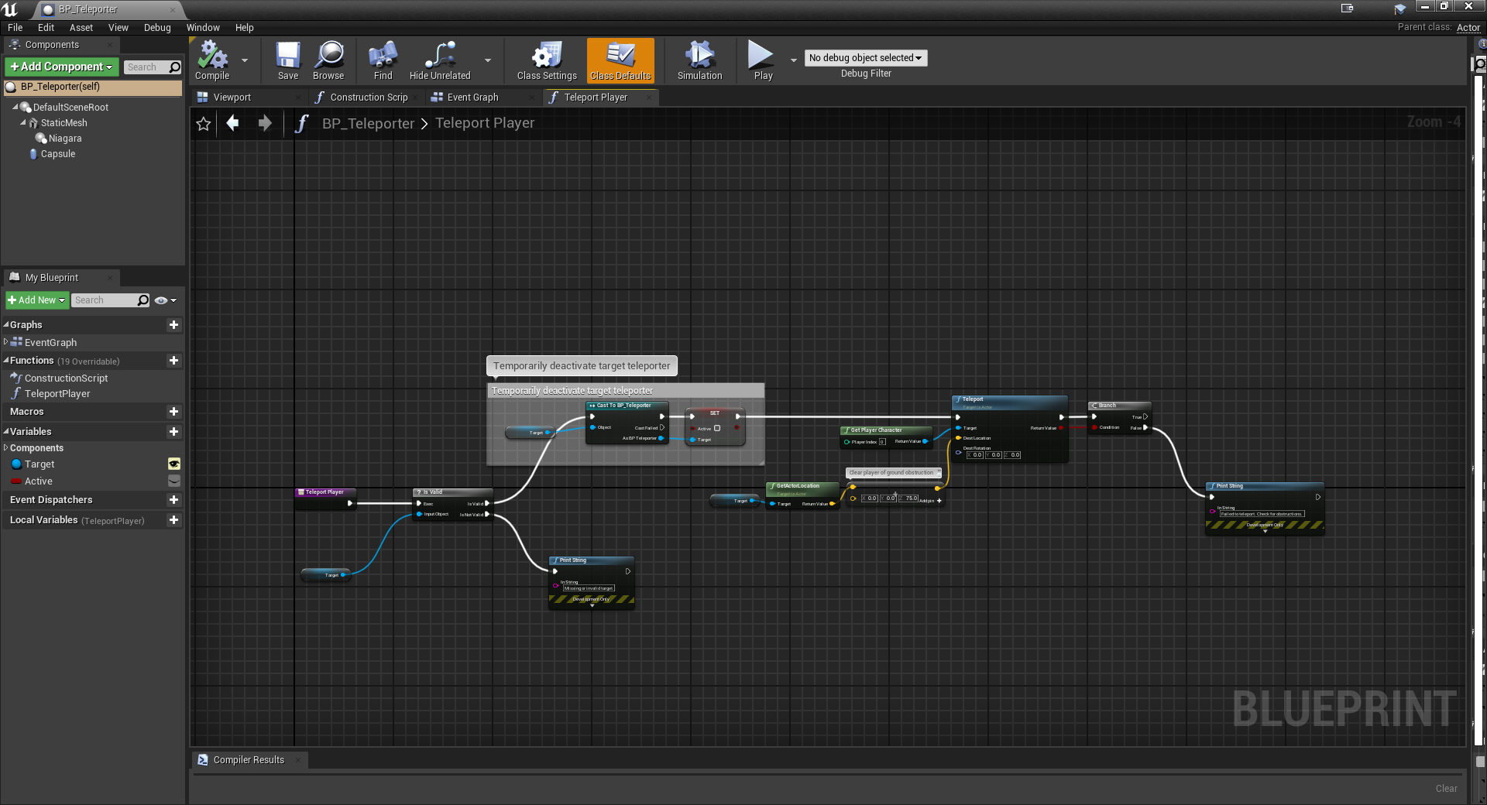

BP_LevelTeleporter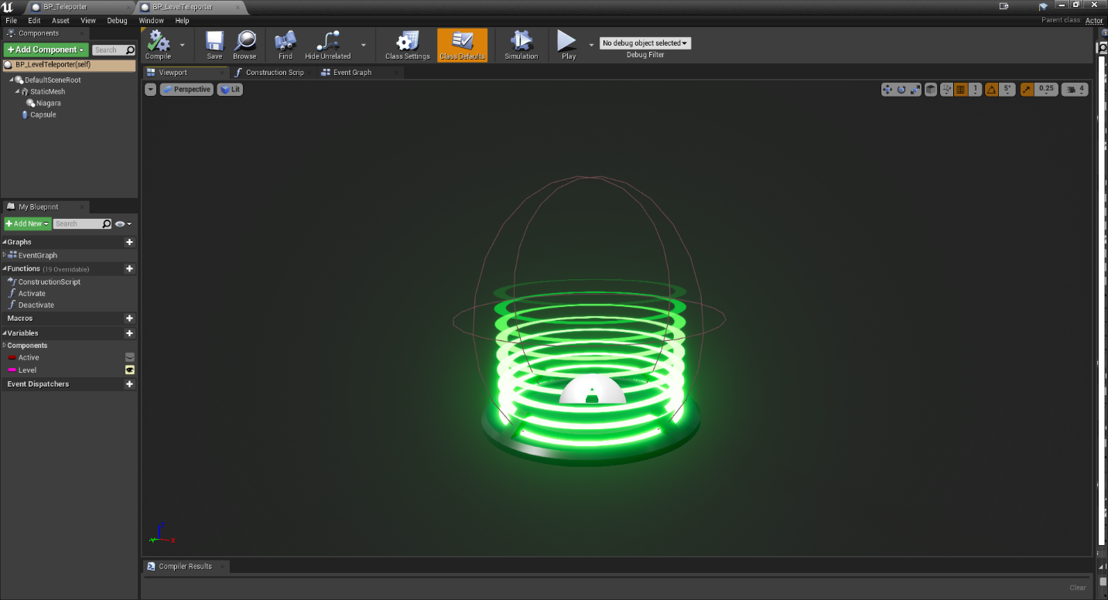

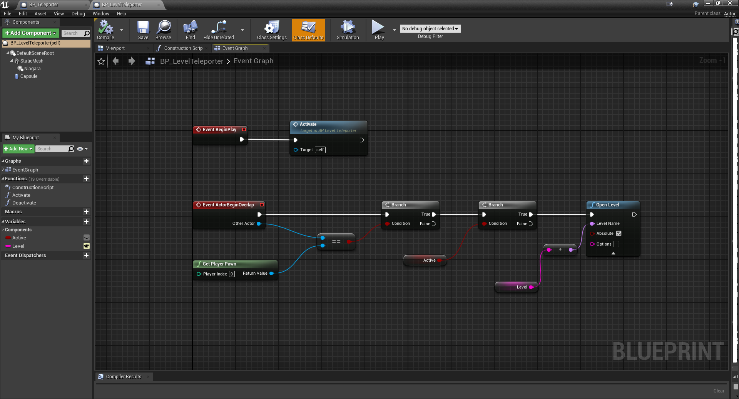

## Requirement: Pawn

**“A Pawn Character with fully working keys using Key Binding, camera and colliders.”**

Our game takes place from a first-person perspective, so the player character is merely a camera, mesh and a collider without an actual model. The player has a full range of movement and can use the F key to toggle their flashlight.

### BP_Player

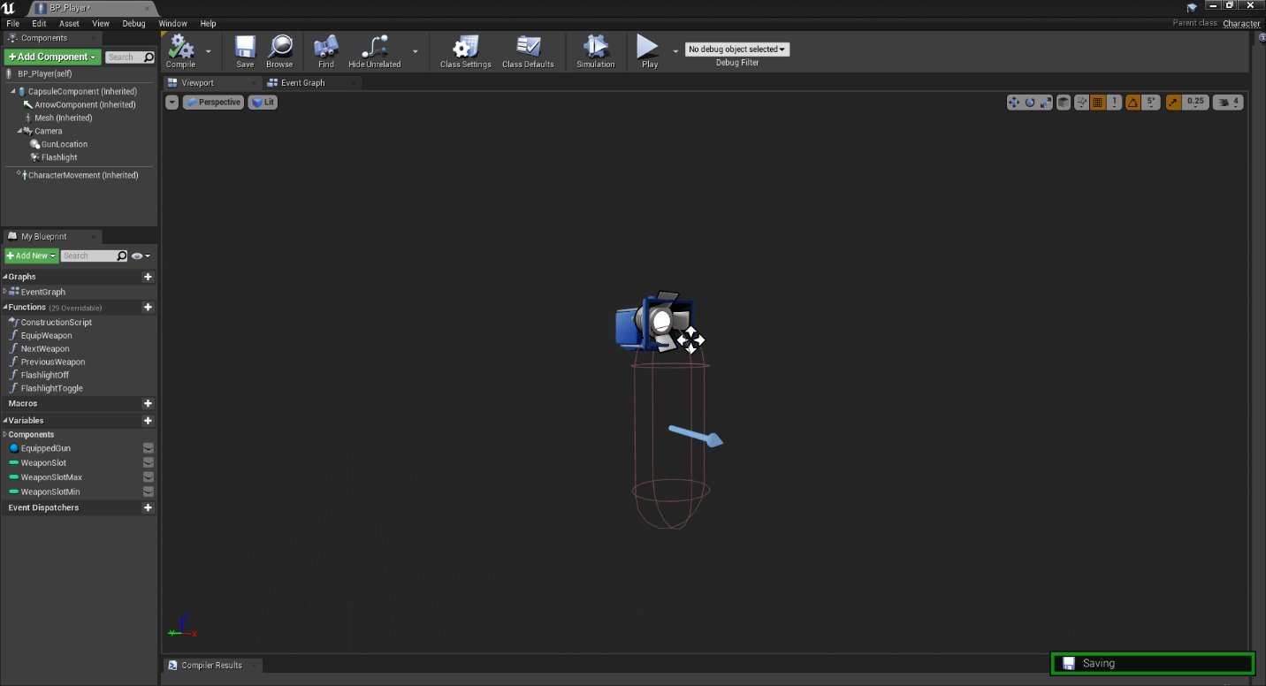

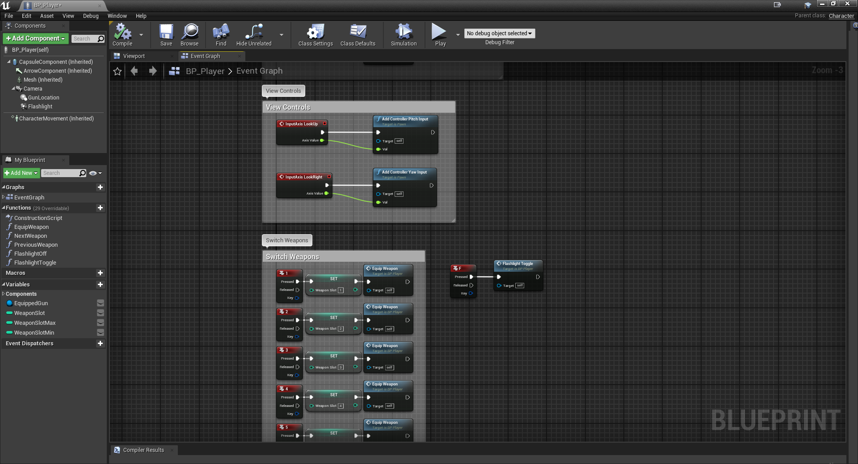

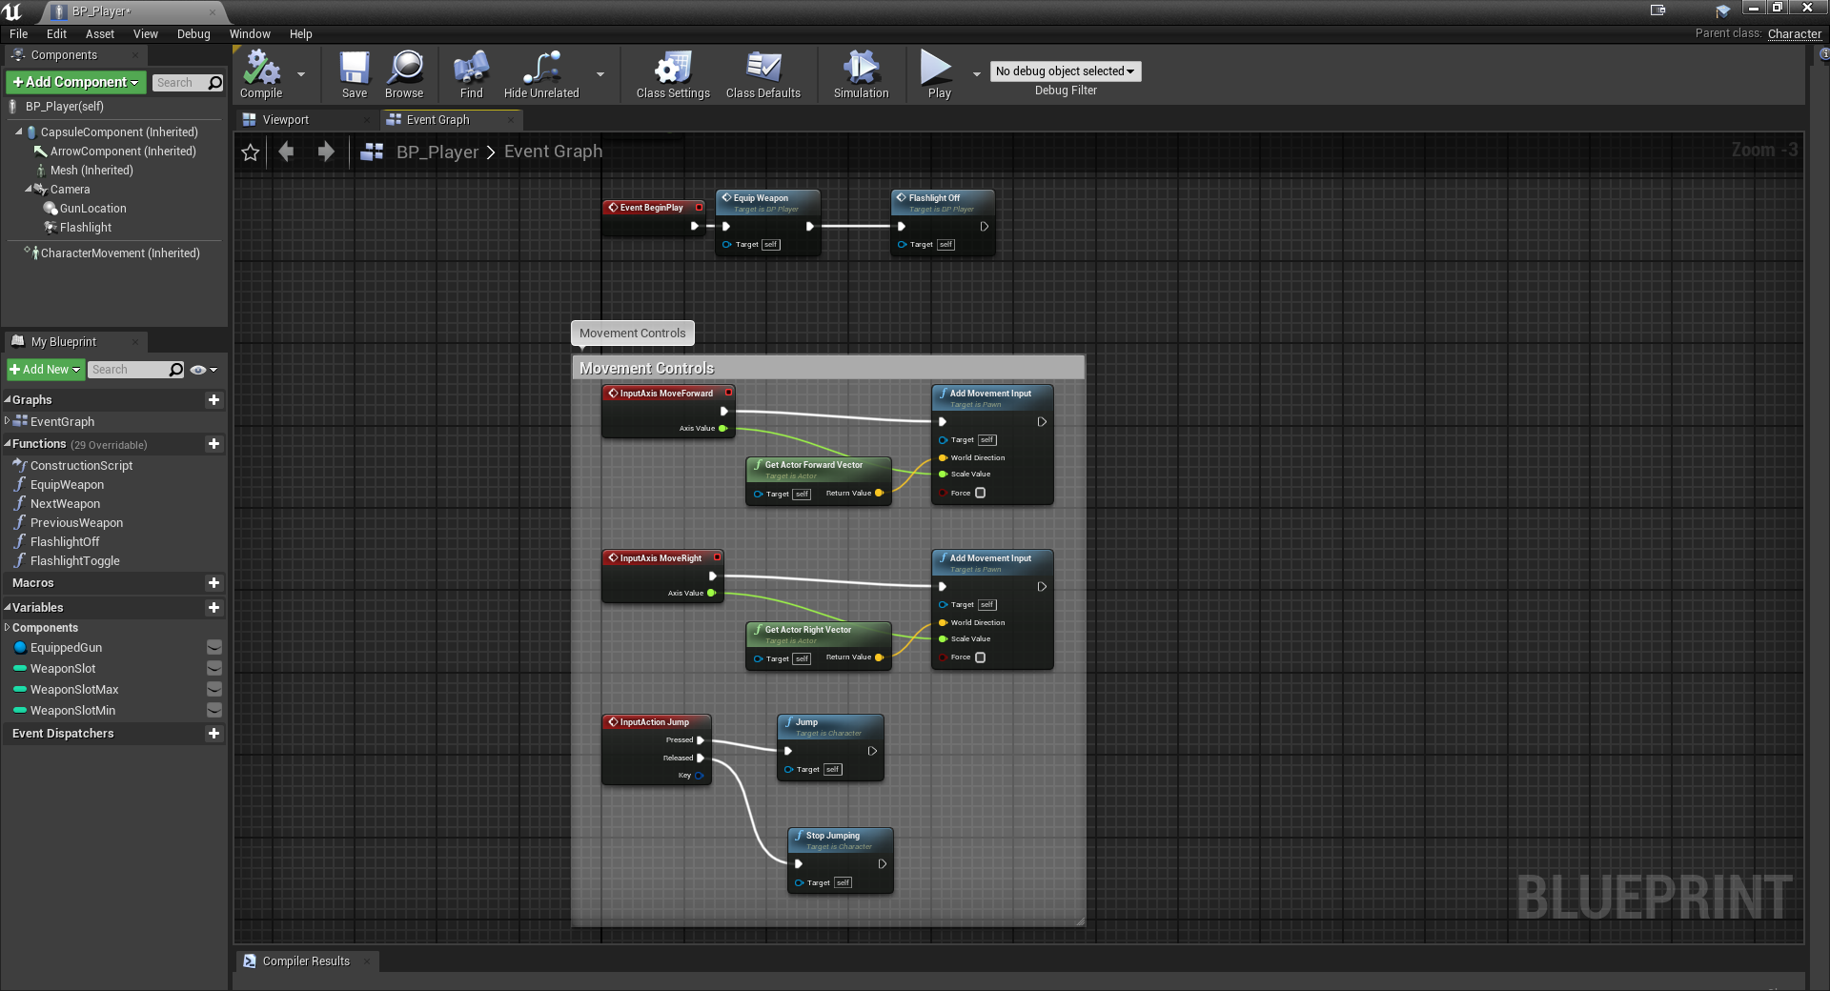

## Requirement: Environmental Lighting

**“Fully implemented lighting that includes at least a skydome, a directional light, and a number of other lights (a exception could be an internal – underground world, where the skydome – directional requirements are dropped).”**

Our game includes a sky sphere, directional light, exponential height fog, post processing volumes sky lights, and point lights to help light the scene and set the atmosphere.

### Dungeon – Lighting

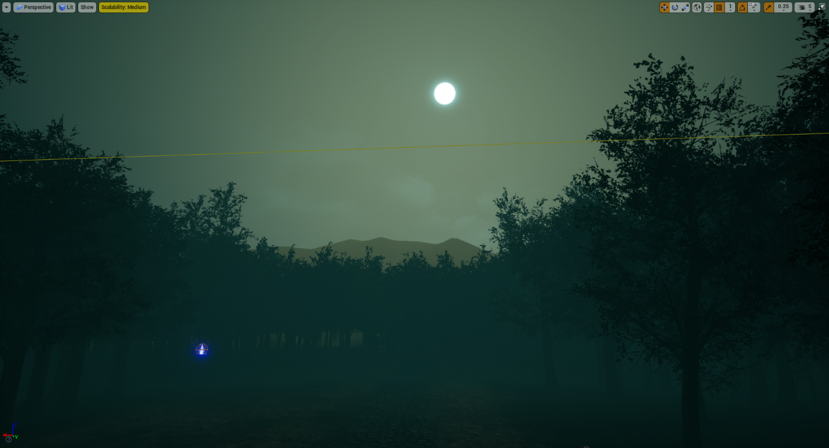



Jungle – Lighting 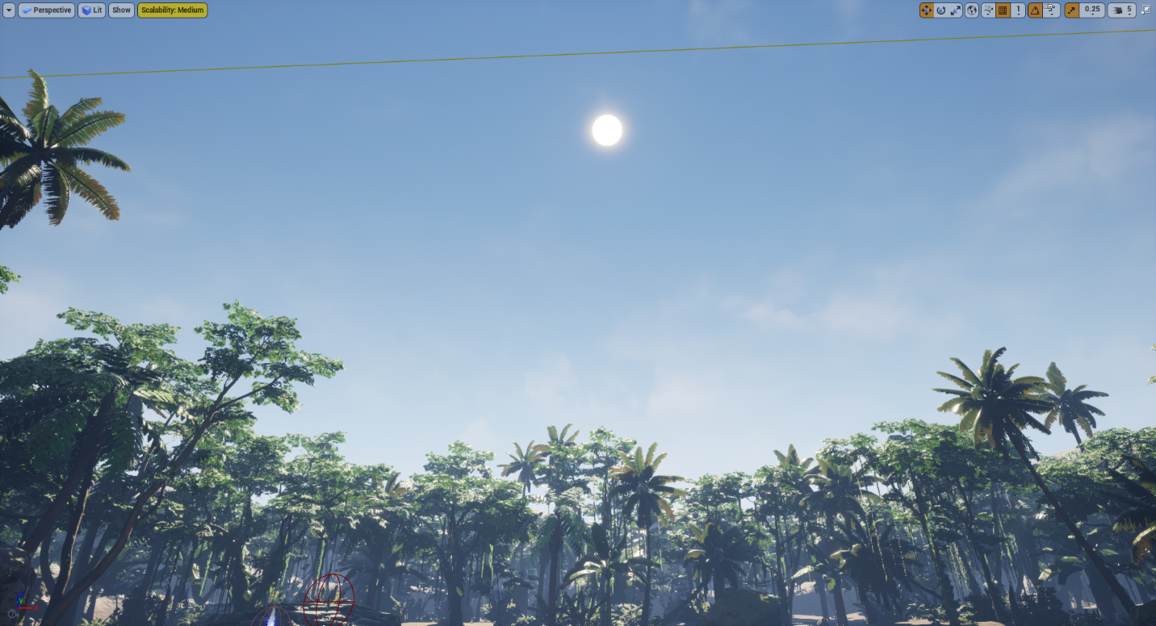

## Requirement: Dynamic Lighting

**“The lights should have some kind of functionality implemented with Blueprints.”**

The player character is equipped with a flashlight that can be toggled using the F key.

### Flashlight

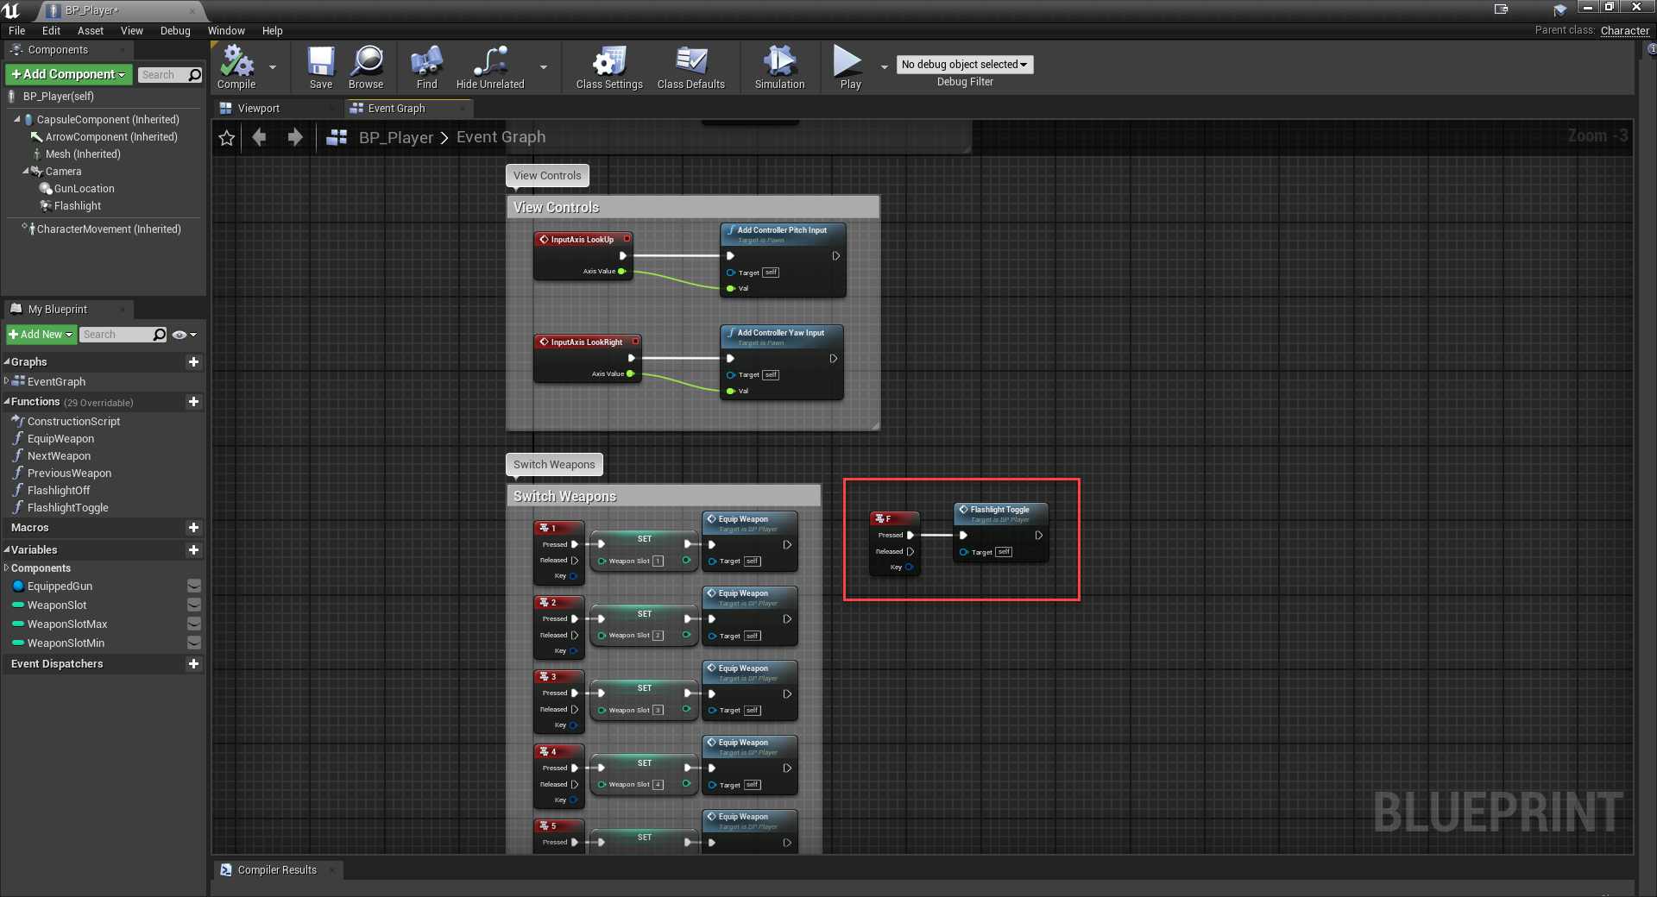

## Requirement: Terrain

**“A simple terrain that can host a game level.”**

Each level has a unique terrain which consists of mountains, trees, plants, and various ground materials to provide a sense of realism.

Jungle

Forest